Lab: Methods
Problems for exercises and homework for the "Programming Fundamentals" course @ SoftUni.
You can check your solutions in Judge.

Declaring and Invoking Methods

Sign of Integer
Create a method that prints the sign of an integer number.

Example
Input | Output
2 | The number 2 is positive.
-5 | The number -5 is negative.
0 | The number 0 is zero.

Grades
Write a method that receives a grade between 2.00 and 6.00 and prints the corresponding grade in words:
- 2.00 – 2.99 - "Fail"
- 3.00 – 3.49 - "Poor"
- 3.50 – 4.49 - "Good"
- 4.50 – 5.49 - "Very good"
- 5.50 – 6.00 - "Excellent"

Examples
Input | Output
3.33 | Poor
4.50 | Very good
2.99 | Fail

Hint
Read the grade from the console and pass it to a method:
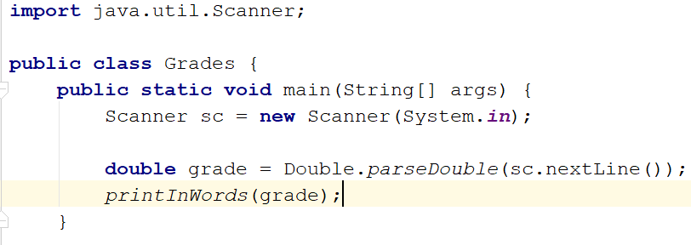
Then create the method and make the if statements for each case:
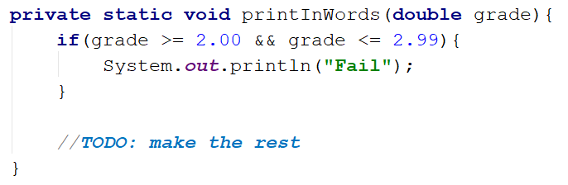

Printing Triangle
Create a method for printing triangles as shown below:

Examples
Input | Output
3 | 1  1 2  1 2 3  1 2  1
4 | 1  1 2  1 2 3  1 2 3 4  1 2 3  1 2  1

Hints
After you read the input, create a method for printing a single line from a given start to a given end. Choose a meaningful name for it, describing its purpose:
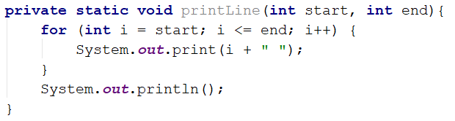
You will need two loops. In the first loop, you can print the first half of the triangle without the middle line:
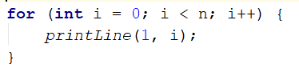
Next, print the middle line:
Lastly, print the rest of the triangle:
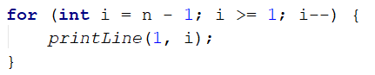

Calculations
Write a program that receives a string on the first line ("add", "multiply", "subtract", "divide") and on the next two lines receives two numbers. Create four methods (for each calculation) and invoke the right one depending on the command. The method should also print the result (it needs to be void).

Example
Input | Output
subtract  5  4 | 1
divide  8  4 | 2

Hints
Read the command on the first line and the two numbers, and then make an if/switch statement for each type of calculation:
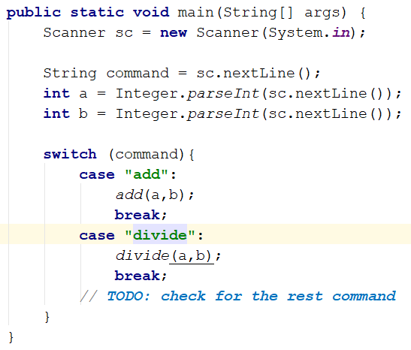
Then create the four methods and print the result:
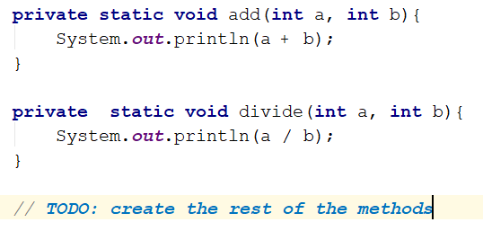

Orders
Write a method that calculates the total price of an order and prints it on the console. The method should receive one of the following products: coffee, water, coke, snacks, and a quantity of the product. The prices for a single piece of each product are:
- "coffee" – 1.50
- "water" – 1.00
- "coke" – 1.40
- "snacks" – 2.00
Print the result rounded to the second decimal place.

Example
Input | Output
water  5 | 5.00
coffee  2 | 3.00

Hint
- Read the product and the quantity.
- Create a method the pass the two variables in.
- Print the result in the method.

Returning Values and Overloading

Calculate Rectangle Area
Create a method that calculates and returns the area of a rectangle by given width and length.

Examples
Input | Output
3  4 | 12
5  7 | 35

Hints
After reading the input, create a method, but this time instead of typing "static void" before its name, type "static double" as this will make it return a value of type double:
Invoke the method in the main and save the return value in a new variable:
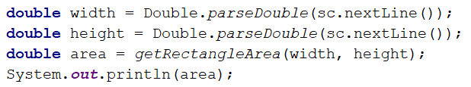

Repeat String
Write a method that receives a string and a repeat count n (integer). The method should return a new string (the old one repeated n times).

Example
Input | Output
abc  3 | abcabcabc
String  2 | StringString

Hints
Firstly read the string and the repeat count n. Then create the method and pass it the variables:
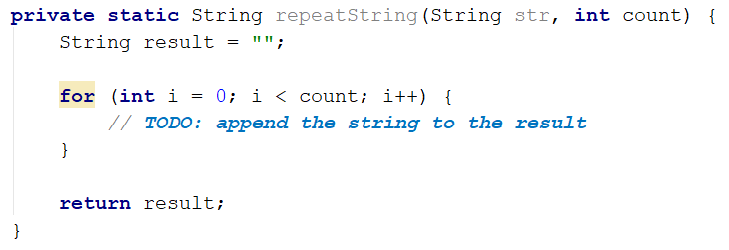

Math Power
Create a method that calculates and returns the value of a number raised to a given power.

Examples
Input | Output
2  8 | 256
5.5  3 | 166.375

Hints
Create a method that will have two parameters - the number and the power, and will return a result of type double:
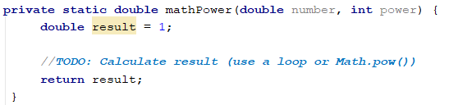
Invoke the method and use DecimalFormat to print the result. For the curious - you can read more here.
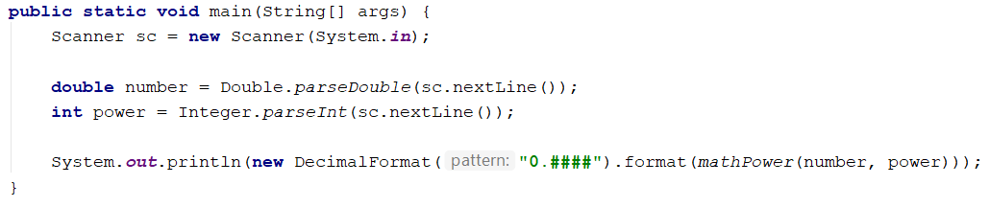

Greater of Two Values
You are given two values of the same type as input. The values can be of type int, char of String. Create a method getMax() that returns the greater of the two values:

Examples
Input | Output
int  2  16 | 16
char  a  z | z
string  Ivan  Todor | Todor

Hints
- You need to create three methods with the same name and different signatures for this method.
- Create a method that will compare integers:
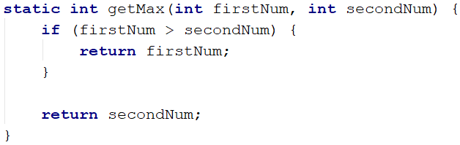
- Create a second method with the same name, which will compare characters. Follow the logic of the previous method:
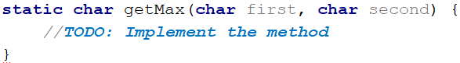
- Lastly, you need to create a method to compare strings. This is a bit different as strings don't allow to be compared with the operators ">" and "<":
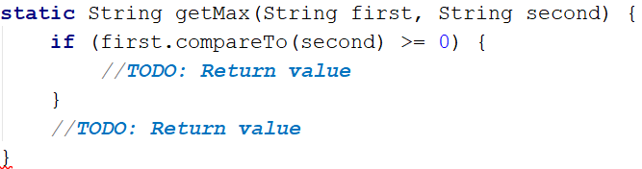
You need to use the method "compareTo()", which returns an integer value (greater than zero if the compared object is greater, less than zero if the compared object is lesser, and zero if the two objects are equal).
- The last step is to read the input. Use appropriate variables and call the getMax() from your main().

Multiply Evens by Odds
Create a program that reads an integer number and multiplies the sum of all its even digits by the sum of all its odd digits:

Examples
Input | Output | Comments
12345 | 54 | 12345 has 2 even digits - 2 and 4. Even digits have a sum of 6.  Also, it has 3 odd digits - 1, 3, and 5. Odd digits have a sum of 9.  Multiply 6 by 9, and you get 54.
-12345 | 54

Hints
- Create a method with a name describing its purpose (like getMultipleOfEvensAndOdds). The method should have a single integer parameter and an integer return value. Also, the method will call two other methods:
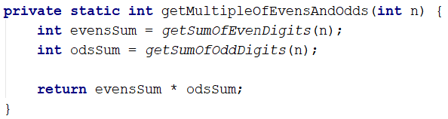
- Create two other methods, each of which will sum either even or odd digits.
- Implement the logic for summing even digits:
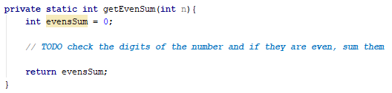
- Do the same for the method that will sum odd digits.
- As you test your solution, you may notice that it doesn't work for negative numbers. Following the program execution line by line, find and fix the bug (hint: you can use Math.abs()).
- Math Operations
Write a method that receives two numbers and an operator, calculates the result, and returns it. You will be given three lines of input. The first will be the first number, the second one will be the operator, and the last one will be the second number. The possible operators are: / * + -
Print the result rounded up to the second decimal point.

Example
Input | Output
5  *  5 | 25
4  +  8 | 12

Hint
Read the inputs and create a method that returns a double (the result of the operation):
